**WMeter Project**

Software Design Document

Names : Gunapala P.C.B.

Thennakoon K.T.A.N.M.

Wijesundara K.P.B.

Workstation : Institute of Java and Software Engineering (Panadura)

Date : 27/01/2017

Table of Contents

Introduction 3

Purpose 3

Scope 3

Overview 3

References 3

System Overview 4

System Architecture 5

Architectural Design 5

Decomposition Description 6

Data Design 10

Data Description 10

Data Dictionary 11

Human Interface Design 13

Final Progress 21

# Introduction

## Purpose

The purpose of this functional and technical requirements document is to provide documentation to give brief introduction, requirement and the plan of the project. The purpose of this project is to measure performance of webpages. This software can be used by web developers to improve the performance of their web applications

## Scope

The scope of this project is measure the performance of a web application which gives the http request and retrieve the output.

## Overview

This project is going to be develop to measure performance of web applications for web developers. This is limited to http requests and output will show using only graphs and tables. This document is contained overall description, software requirements, design constraints and interfaces that going to be used in this project.

## References

Apache JMeter Documentation

[www.tutorialspoint.com](http://www.tutorialspoint.com)

[www.youtube.com](http://www.youtube.com)

# System Overview

**Product Function**

Web performance measuring system has only one actor and cooperating system. Web developer is the only one user who can communicate with system by using the web page.

Functional requirements specifications outlines the use cases in the system. Mainly web developer has three main use cases give request, select listener and add timer.

**User characteristics**

The user must be a web developer. The user is expected to be Internet literate and be able to use a search engine. The output is given by a table or a graph so, user should be able to understand them and get an idea about the performance of their application.

**Constraints**

Requested output can be delay due to connection problems.

Developing errors in web application which are going to be checked can be affected to this application.

**Assumptions and dependencies**

Connections problems will not occur.

User is with all characteristics above described.

User is able to communicate with application easily.

# System Architecture

## Architectural Design

MVC STRUCTURE

Database

UI Layer

Cross Cutting

DAO Layer

Business Layer

Service Layer

Controller Layer

* UI Layer

Customer will interact with only this layer. This application is a web based, website is the UI. HTML, CSS and JavaScript will be used mainly to design this layer. Boostrap framework will be used.

* Controller Layer

This layer will interact with both UI and Service Layers.

* Service Layer

This will make a connection between client and server.

* Business Layer

All business logics are contained here.

* DAO Layer

This layer will make a connection to the database.

* Cross Cutting

DTO and Exception handling part will be there.

This structure is used to design our application with low coupling and high cohesion.

## Decomposition Description

Functional description

Use case 1: User gives a request

Main Flow

1. User starts work with webpage.
2. User selects check web performance option.
3. System requests user inputs to Thread Group page.
4. User enters data to required fields.
5. System validates user’s inputs.
6. System displays a message to add listener to the test plan.

Alternative flow 5a: User enters invalid data

1. System tells user that the values entered is invalid.
2. Return to Main Flow step 3.

Alternative flow 5b: User exceeds the free limit of using the application.

1. System tells user that the free limit is exceeded and create an account.
2. Follow the use case 4.
3. Return to Main Flow step 3.

Use case 2: User selects a listener.

Main Flow

1. User selects “add listener” tab and selects desired listener type either table or graph.
2. Systems displays listener page as requested by user.
3. System requests insert data into required fields.
4. User enters data into required fields.
5. System validates user’s input.
6. System displays a message to add timer to test plan.

Alternative flow 4a: User enters invalid data

1. System tells user that the values entered is invalid.
2. Return to Main Flow step 2.

Use case 3: User selects a timer.

Main Flow

1. User selects “Add Timer” tab and selects desired timer, as either constant timer or constant throughput timer.
2. System displays Timer page.
3. System requests insert data into required fields.
4. User enters data.
5. System validates user’s input.
6. System displays the performance of the web application as either table or a graph.

Alternative flow 5a: User enters invalid data

1. System tells user that the values entered is invalid.
2. Return to Main Flow step 3.

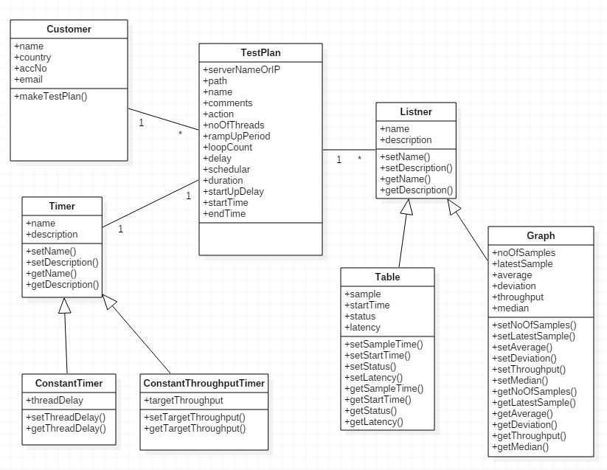 Class Diagram

Data Flow Diagram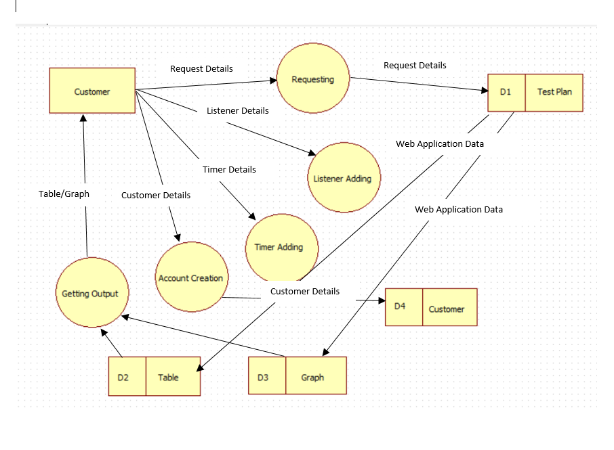

Structural Decomposition Diagram

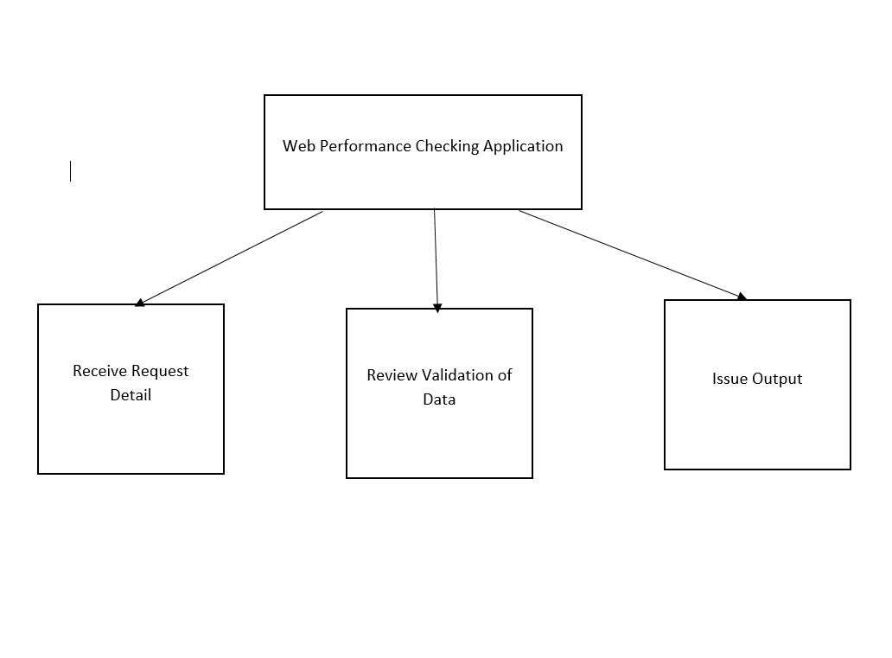

# Data Design

## Data Description

Create database WMeter;

Use WMeter;

Create table TestPlan(

ActionType VARCHAR(20) NOT NULL,

NoOfThreads INT,

RampUpPeriodInSeconds INT,

LoopCount INT,

DelayThreads BOOLEAN,

SchedulerDurationInSeconds INT,

SchedulerStartUpDelayInSeconds INT,

StareTime DATETIME,

EndTime DATETIME,

Listener VARCHAR,

Timer VARCHAR

);

Create table Table (

Sample VARCHAR NOT NULL,

StartTime TIME NOT NULL,

SampleTime TIME NOT NULL,

Status VARCHAR NOT NULL,

Bytes INT NOT NULL,

SentBytes INT NOT NULL,

Latency TIME NOT NULL,

ConnectTime TIME NOT NULL

);

Create table Graph (

NoOfSamples INT NOT NULL,

LatestSample VARCHAR(10) NOT NULL,

Average DECIMAL NOT NULL,

Deviation DECIMAL NOT NULL,

Throughput DECIMAL NOT NULL,

Median DECIMAL NOT NULL,

);

Create table Customer(

AccNo VARCHAR(20) NOT NULL,

Name VARCHAR(50),

Country VARCHAR(50),

Email VARCHAR(50),

CONSTRAINT PRIMARY KEY (AccNo)

);

## Data Dictionary

**Test plan**

|  |  |  |
| --- | --- | --- |
| **Field** | **Type** | **Condition** |
| Action Type | VARCHAR | NOTNULL |
| No of Threads | INT | NOTNULL |
| Ramp up Period | INT | NOTNULL |
| Loop Count | INT | NOTNULL |
| Delay Threads | BOOLEAN |  |
| Shedular Duration | INT |  |
| Shedular Starup Delay | INT |  |
| Start Time | DATETIME |  |
| End Time | DATETIME |  |
| Listener | VARCHAR |  |
| Timer | VARCHAR |  |

**Table**

|  |  |  |
| --- | --- | --- |
| **Field** | **Type** | **Condition** |
| Sample | VARCHAR | NOTNULL |
| Start Time | TIME | NOTNULL |
| Sample Time | TIME | NOTNULL |
| Status | VARCHAR | NOTNULL |
| Bytes | INT | NOTNULL |
| Sent Bytes | INT | NOTNULL |
| Latency | TIME | NOTNULL |
| Connect Time | TIME | NOTNULL |

**Graph**

|  |  |  |
| --- | --- | --- |
| **Field** | **Type** | **Condition** |
| no OF Samples | INT | NOTNULL |
| Latest Sample | VARCHAR | NOTNULL |
| Average | DECIMAL | NOTNULL |
| Deviation | DECIMAL | NOTNULL |
| Throughput | DECIMAL | NOTNULL |
| Median | DECIMAL | NOTNULL |

**Customer**

|  |  |  |
| --- | --- | --- |
| **Field** | **Type** | **Condition** |
| Acc No | VARCHAR | NOTNULL , Primary key |
| Name | VARCHAR |  |
| Country | VARCHAR |  |
| Email | VARCHAR |  |

# Human Interface Design

There are 8 main interfaces including the application.

* Home page
* Thread group page
* Listener (Graph) page
* Listener (Table) page
* Timer page
* Customer account page

**Home page**

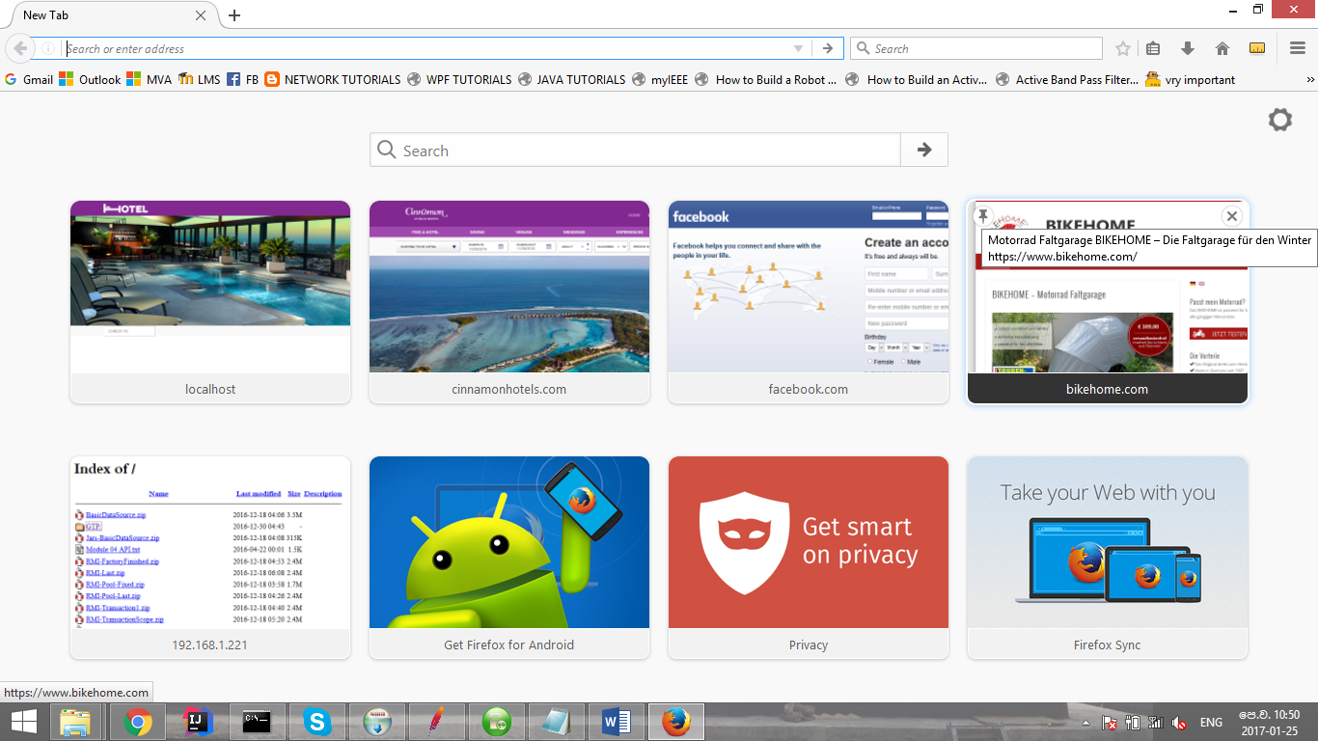

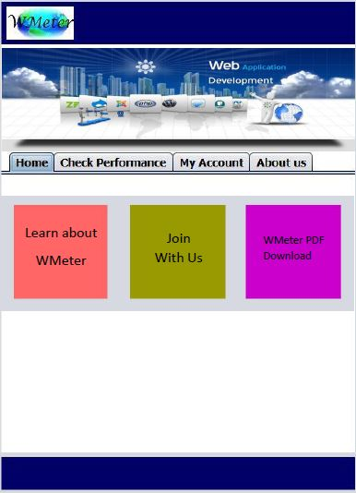

1

9

8

7

6

4

5

2

Contact us

B,mn

3

1. Home key: This button is a link to home page. When press this button, return to home page from any page in the application. When mouse over, the icon will highlighted.
2. Contact us link: When mouse click on this link, our contact details will popup. When mouse over, the link will highlighted.

Mail:

Facebook:

By following Facebook page any one can get more details about WMeter and new updates.

1. Banner: This is the slide show banner.
2. WMeter logo: This button is also link to the home page.
3. Title bar: The title bar is represented all main pages in the application and the tab that belongs currently selected page get different color to highlight.
4. Learn about WMeter box: When mouse click on this box, the page include main steps will opened. When mouse over, the box will highlighted.
5. Join with us box: When mouse click on this box, my account tab will opened automatically. When mouse over, the box will highlighted.
6. WMeter pdf download box: When mouse click on this box, a pdf that include all details about WMeter will downloaded.
7. The bar placed to end of the page: This bar includes phone number, email address.

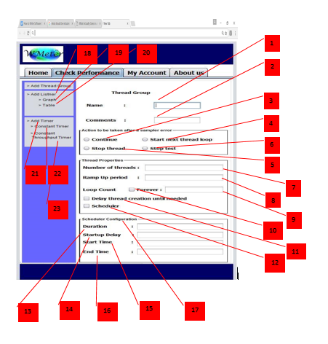**Thread Group page**

1. Server name or IP: A text field that require server name or IP (Home page) that measured the performances.
2. Path: A text field that require path of the web page.
3. Name: A text field that include name of the Thread group
4. Comment: A text field that include a comment about the thread group

**Action to be taken after sampler error (Default selected button is continue) :**

1. Continue: A radio button. When select this, go to next element of the test after sampler error.
2. Start next thread loop: A radio button. When select this, go to next thread loop after sampler error.
3. Stop thread: A radio button. When select this, stop thread after sampler error.
4. Stop test: A radio button. When select this, stop test fully after sampler error.

**Thread Properties**

1. No of Threads: A text field that include no of users of the web site for the test. The default value is 1.
2. Ramp up period: A text field that include ramp up period in seconds. Ramp up period is the time to be taken for getting all threads. The default value is 1.
3. Loop count: A text field that include integer number for loo count. Loop count is how many times that take to execute the test. The default value is 1.
4. Forever: A check box that display the loop count is infinite.
5. Delay thread creations until needed: A check box that display that delay is taken or not between threads creations.
6. Scheduler: The check box that display that scheduler is taken or not for a thread.
7. Scheduler Configuration box: When the scheduler check box is selected, the scheduler configuration box is enabled.
8. Duration: A text field that include duration that time is got for the thread in seconds.
9. Startup delay:
10. Start time: A text field that include start time of the thread.
11. End time: A text field that include end time of the thread.
12. Add thread group: A link to the thread group page. When mouse over, the link is highlighted.
13. Add listener (Graph): A link to the listener (graph) page. When mouse over, the link is highlighted.
14. Add listener (Table): A link to the listener (table) page. When mouse over, the link is highlighted.
15. Add timer: A link to the timer page. When mouse over, the link is highlighted.
16. Confirm: A button to confirm the thread group.
17. Cancel: A button to delete all in thread group.

**Listener (Table) page**

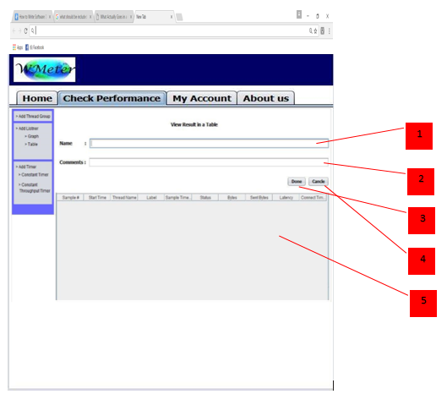

1. Name: A text field that includes a name to the table.
2. Comment: A text field that includes a small description about table.
3. Done: A button to submit the table.
4. Cancel: A button to cancel the table.
5. Table: The table of output. The latency is the parameter that give the speed of the web page.

**Listener (Graph) page**

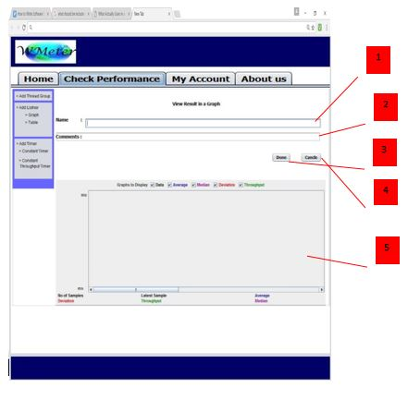

1. Name: A text field that includes a name to the graph.
2. Comment: A text field that includes a small description about graph.
3. Done: A button to submit the graph.
4. Cancel: A button to cancel the graph.
5. Table: The graph of output. The throughput is the parameter that give the speed of the web page.

**Timer page**

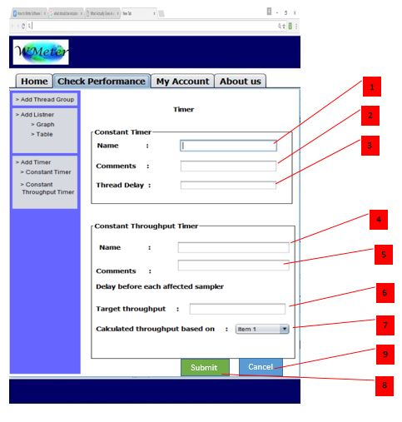

**Constant timer:**

1. Name: A text field that includes name of the timer.
2. Comments: A text field that includes comments about the timer.
3. Thread delay: A text box that includes delay between threads.

**Constant Throughput timer:**

1. Name: A text field that includes name of the timer.
2. Comments: A text field that includes comments about the timer.
3. Target Throughput: A text box that includes target throughput of threads.
4. Submit: A button to submit the timer.
5. Cancel: A button to cancel the timer.

**Account page**

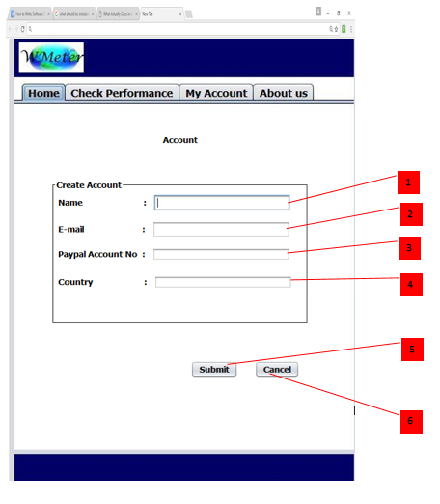

1. Name: A text box that includes name of the customer.
2. E-mail: A text box that includes email of the customer.
3. Acc no: A text box that includes account number.
4. Country: A text box that includes name of the country.

# Final Progress

* The backend part of the project is totally completed.
* Data is written on a file.
* This data can be written on a file by inserting URL and number of users to the main method of the JMeterTestPlanBOImpl class.

TODO

* Front end should be completed.
* Input data should be added to our database.
* The data in above file should be displayed in a graph or a table.